Negative Feedback, Homeostasis, and Positive Feedback

How is your body temperature regulated?

Your body maintains a relatively constant body temperature, even when the external environment gets colder or hotter. Answer question 1 to describe why this is useful.

1a. What could go wrong if your body temperature got too high?

1a. What could go wrong if your body temperature got too low?

2. Answer the questions in these flowcharts to describe how your body’s responses prevent body temperature from getting too low or too high.
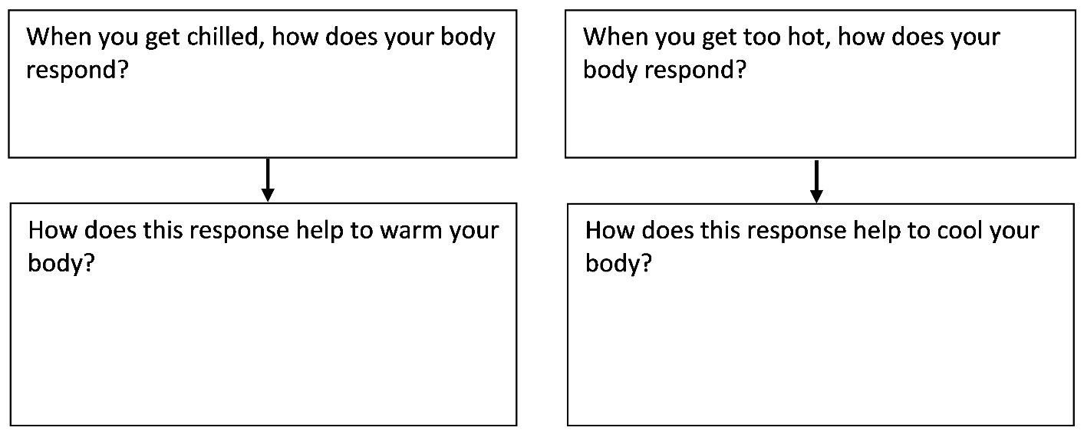

3. There is a temperature control center in the brain. Propose a hypothesis about how this temperature control center keeps body temperature in the optimum range. | 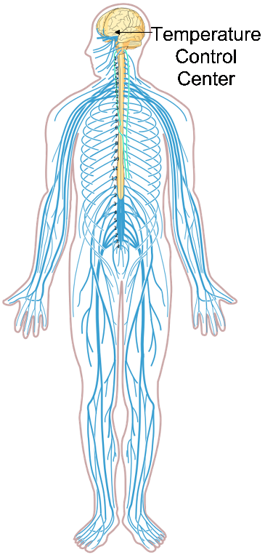

- The temperature control center in your brain keeps your body temperature near a set point. Usually, the set point for body temperature is approximately 37°C (~37°C = ~98.6°F).

- The temperature control center compares this set point to actual body temperature (measured by temperature receptors in the brain and other parts of the body).

- If your body temperature gets too low or too high, then the temperature control center triggers a response that brings your body temperature back to the set point.

4. Complete this flowchart to summarize how a person’s temperature control center can keep his or her body temperature close to the set point of ~37° C.

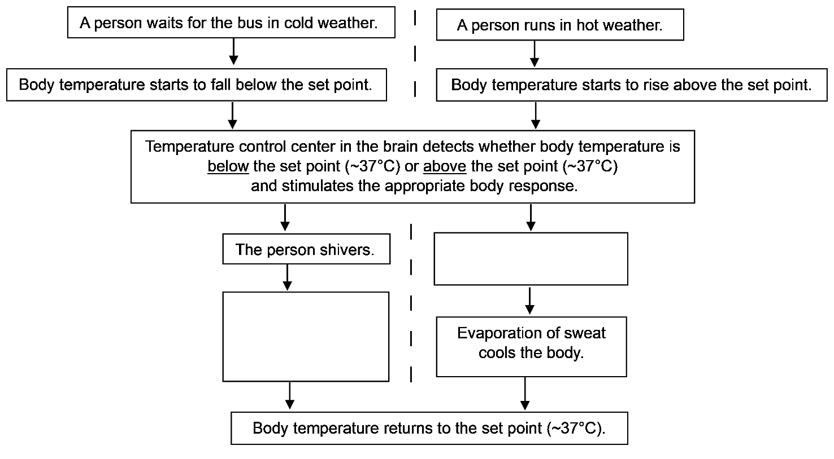

5. Negative feedback is defined in the first row of the figure below. Complete the second and third rows to show that body temperature regulation is an example of negative feedback.

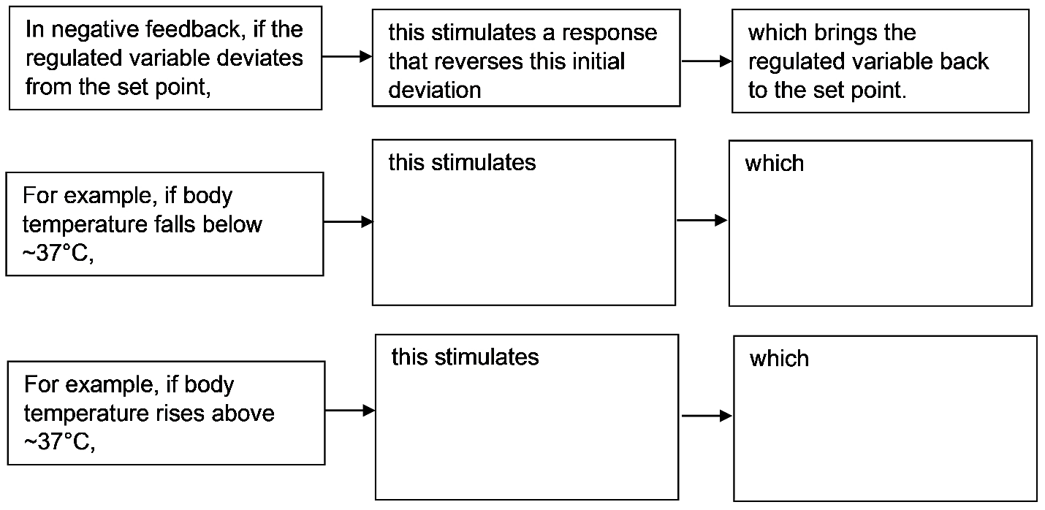
- When your warm blood flows through the surface blood vessels in your skin, it warms your skin which radiates heat away from your body.
- When more blood flows through these surface blood vessels, more heat is lost from your body.
- The amount of blood flow through these surface blood vessels is regulated by your temperature control center as part of the negative feedback regulation of your body temperature.
6a. Which diagram shows the pattern of blood flow that would be expected when a person is in a cold environment?  A ___ B___  6b. Explain your reasoning. | 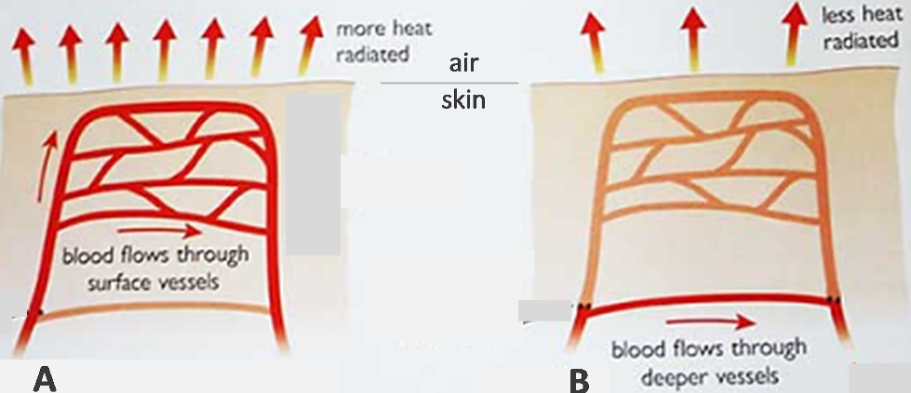

6c. Complete the flowchart in question 4 by adding increased and decreased blood flow through surface blood vessels.

This figure is another way of showing negative feedback regulation of body temperature.  7a. Fill in the blank boxes to describe the body’s responses to changes in body temperature. | 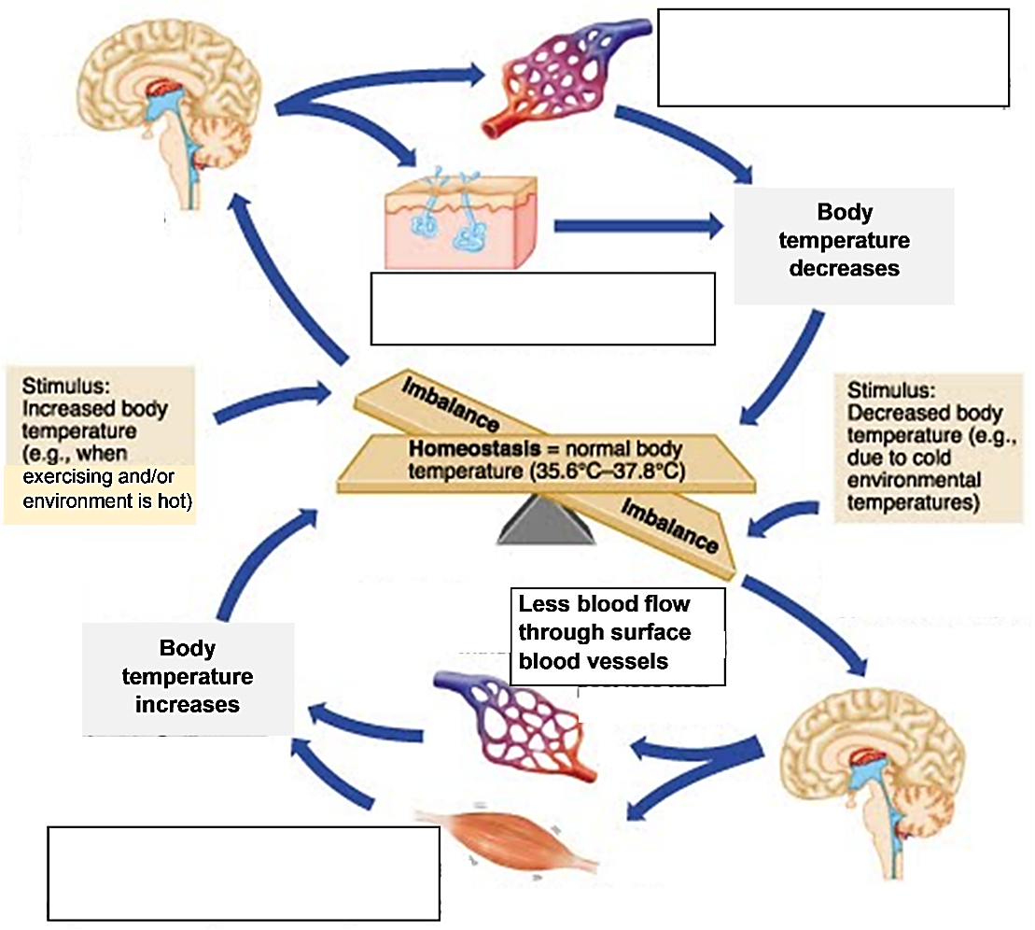

7b. Notice that the same information can be presented in different formats. The top half of this figure corresponds to the __________ half of the flowchart in question 4.
(left / right)
Your body maintains relatively constant levels of many variables. For example, your body maintains relatively constant body temperature and relatively constant levels of CO₂, H⁺ and glucose in your blood. This maintenance of relatively constant internal conditions is called homeostasis.

8. How does negative feedback contribute to homeostasis?

Homeostasis and negative feedback do not mean that body temperature is always constant. For example, when you have an infection, your body temperature may increase and you may develop a fever. The fever helps your immune system fight the infection. This flowchart shows how a person who has an infection develops a fever.
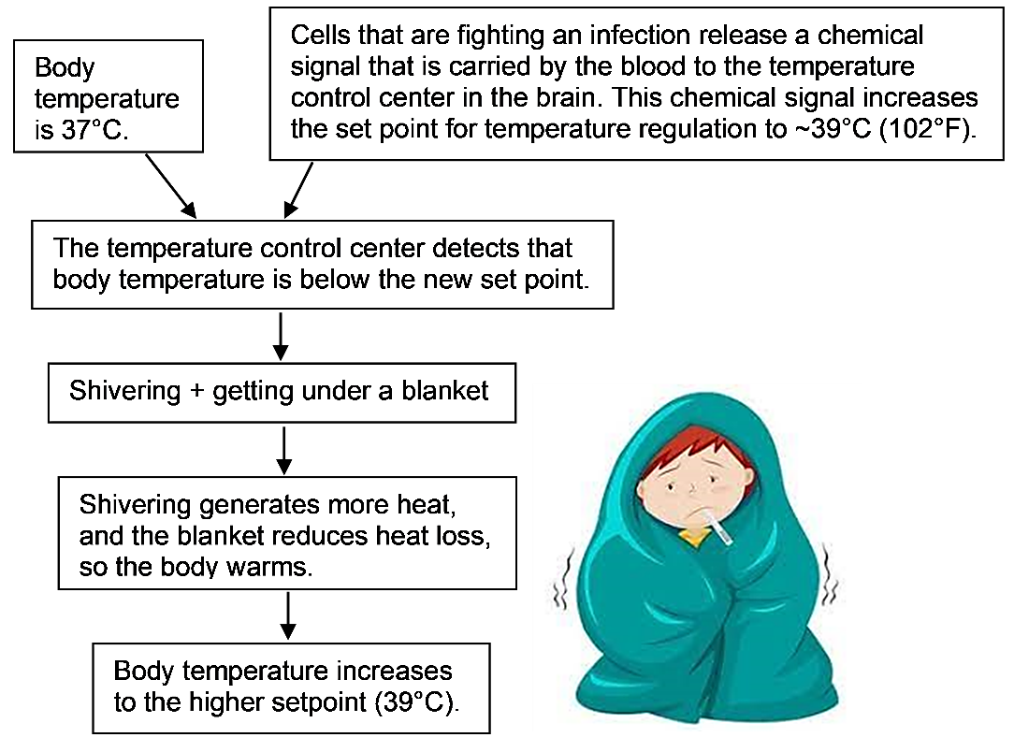
9. Notice that the person described in this flowchart is shivering, even though his body temperature is at the normal set point (37°C). Explain why he is shivering.

Diabetes – A Failure of Negative Feedback Regulation of Blood Glucose Levels

When negative feedback doesn’t work correctly, this can result in illness. For example, defects in negative feedback regulation of blood glucose levels can result in diabetes. In a person with diabetes, too much glucose in the blood injures blood vessels and nerves, which can cause heart disease, kidney disease, stroke, and/or blindness.

10. What problems could result if a person’s blood glucose levels get too low, so the person’s cells do not get enough glucose?

This figure shows normal negative feedback regulation that prevents blood glucose levels from rising too high or falling too low.
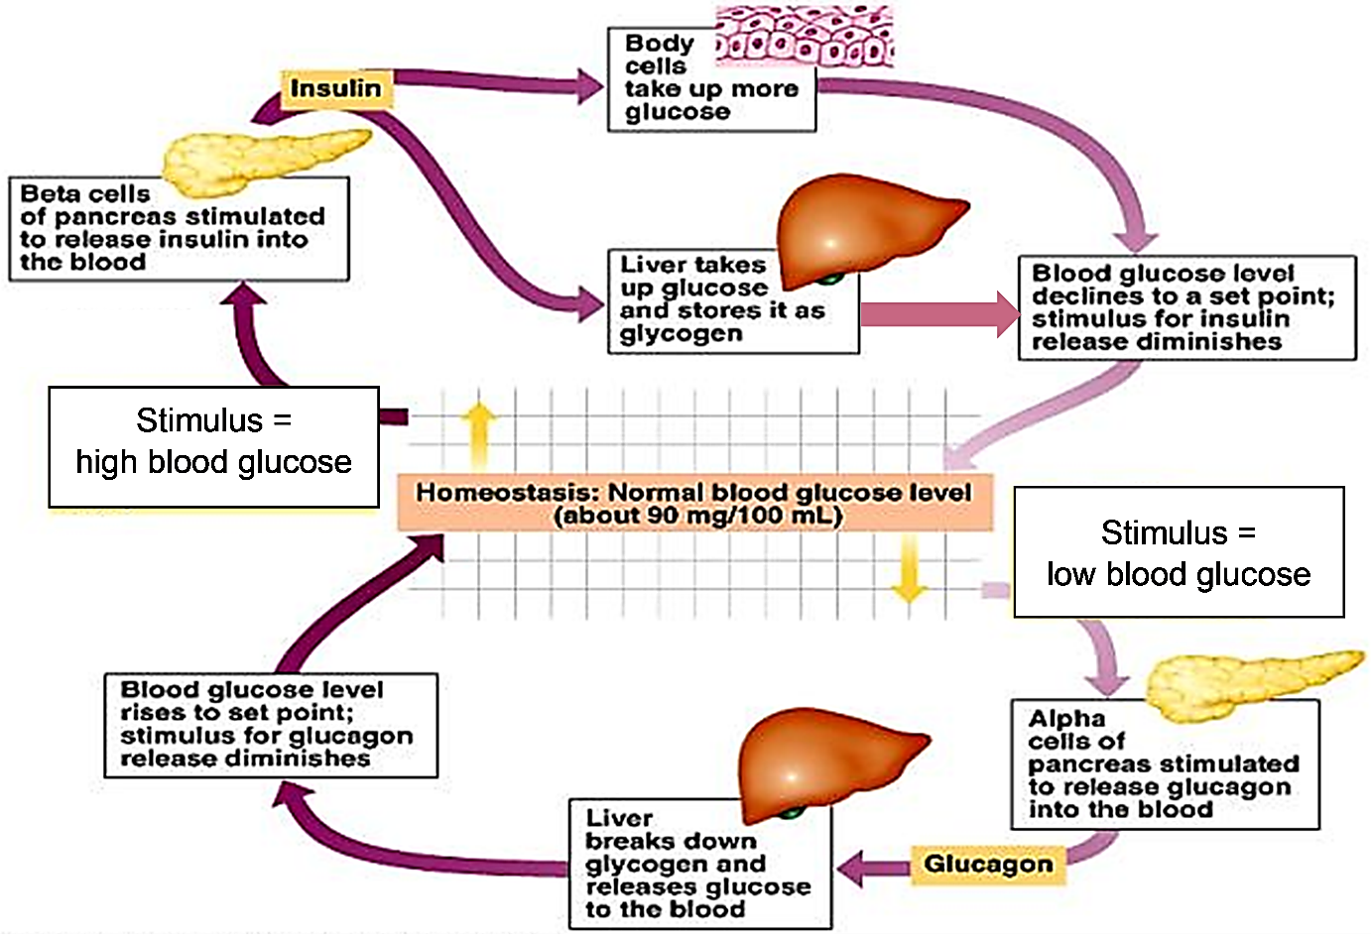

11a. When blood glucose levels are high, excess glucose is stored in glycogen, which is a polymer of glucose. Write polymer next to glycogen in the figure.
11b. Insulin and glucagon are hormones, which are chemical messengers that travel in the blood. Write hormone next to insulin and glucagon in the figure.

12a. After a person eats a meal, glucose is absorbed from the gut into the blood. Describe the physiological responses that prevent an excessive rise in blood glucose levels after a meal.

12b. When a person has not eaten for a long time, what physiological responses help to prevent blood glucose levels from falling too low?

13a. In a person with type 1 diabetes, the pancreas can’t secrete insulin. Which effect would the lack of insulin have? higher than normal blood glucose levels ___ lower than normal ___
13b. Explain your reasoning.

14. Type 2 diabetes begins with insulin resistance (defined in this flowchart). Fill in the blanks.
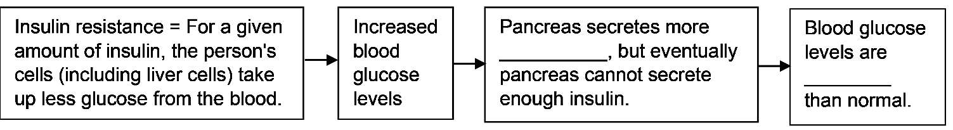
Positive feedback produces rapid change.
In positive feedback, an initial change stimulates more change in the same direction. Thus, positive feedback amplifies an initial change. The result is rapid change.

For example, this figure shows how positive feedback contributes to the rapid formation of a platelet plug when a blood vessel has been injured.  ● Blood contains platelets, which stick to  injured blood vessel tissue.  ● When platelets stick to injured tissue, they  begin to secrete chemical signals that  attract more platelets.  ● Many platelets accumulate quickly and  plug the hole in the injured blood vessel.  15. Explain how positive feedback helps to prevent excessive blood loss after a blood vessel has been injured. | 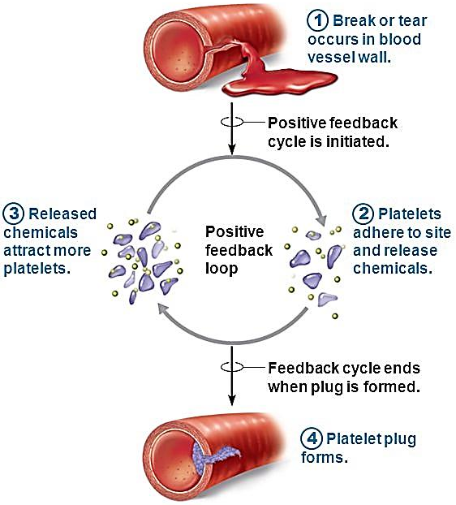

16. Complete this table to describe two ways that positive feedback is the opposite of negative feedback. Fill in each blank, using these responses:
close to a set point / rapid change / reverses / same.

Positive Feedback | Negative Feedback
An initial change stimulates more  change in the ________ direction. | An initial change away from the set point stimulates a  response that ______________ the initial change.
Positive feedback produces  _________________________. | Negative feedback keeps a regulated variable (e.g.,  body temperature) _____________________________.

17a. If you are cold, shivering helps to increase your body temperature. Is shivering part of positive feedback ___ or negative feedback ___?

17b. Explain your reasoning.

18. Explain why positive feedback and negative feedback are appropriate names for these two different types of feedback.

By Dr. Ingrid Waldron, Dept Biology, Univ Pennsylvania, © 2023. This Student Handout and Teacher Notes with background information and instructional suggestions are available at http://serendipstudio.org/exchange/bioactivities/homeostasis.

